**THE PATTERNS COMPANY**

4th Floor, Bizness Square Junction Opposite Hitex Road, HITEC City, Madhapur, Hyderabad, Telangana 500084

+91-8500693113

+91-9392744210

[info@thepatternscompany.com](mailto:info@thepatternscompany.com) https://[www.thepatternscompany.com/](http://www.thepatternscompany.com/)





Website Report for [www.himagirihospitals.com](http://www.himagirihospitals.com/)

This report grades your website based on the strength of various SEO factors such as On Page Optimization, O Page Links, Social and more. The overall Grade is on a A+ to F- scale, with most major, industry leading websites in the A range. Improving your grade will generally make your website perform better for users and rank better in search engines. There are recommendations for improving your website at the bottom of the report. Feel free to reach out to us if you’d like us to help with improving your website’s SEO!

Audit Results for [www.himagirihospitals.com](http://www.himagirihospitals.com/)



**C-**

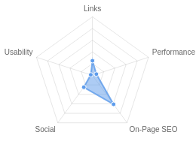**Your page could be better**

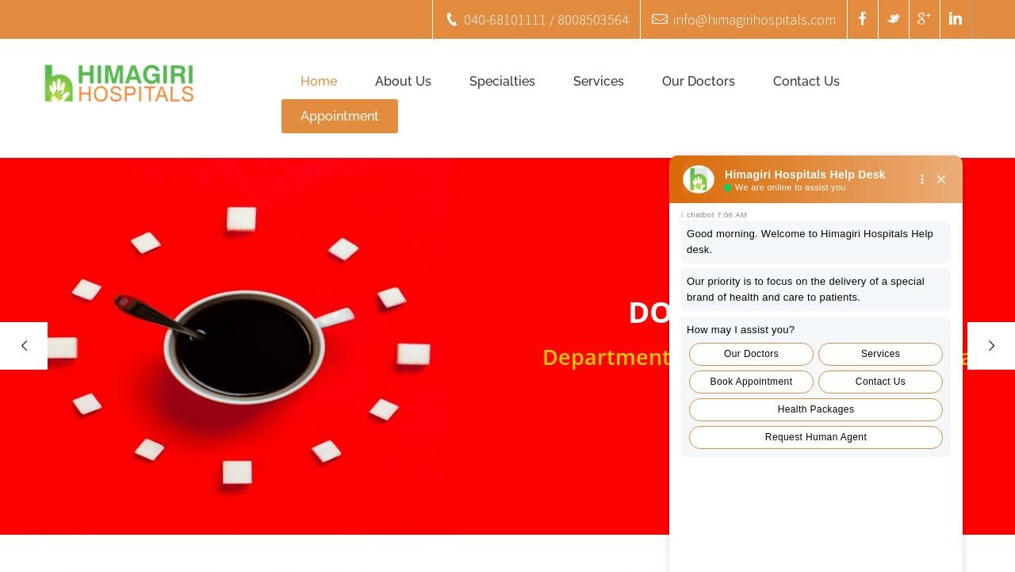

Recommendations: 24



**B**



**D**



**F**



**F**



**D**

On-Page SEO

Links

Usability

Performance

Social

Recommendations

# Include a meta description tag

On-Page SEO

High Priority

**Execute a Link Building Strategy**

Links

High Priority

# Reduce your total page file size

Performance

Medium Priority

|  |  |  |
| --- | --- | --- |
| **Optimize for Core Web Vitals** | Usability | Medium Priority |
| **Improve site load speed** | Performance | Medium Priority |
|  |  |  |
| **Reduce length of title tag (to between 10 and 70** | On-Page SEO | Medium Priority |
| **characters)** |  |  |
| **Use your main keywords across the important HTML tags** | On-Page SEO | Low Priority |
|  |  |  |
| **Add Alt attributes to all images** | On-Page SEO | Low Priority |
|  |  |  |
| **Optimize your images to reduce their file size** | Performance | Low Priority |
| **Optimize your page for Mobile PageSpeed Insights** | Usability | Low Priority |
| **Optimize your page for Desktop PageSpeed Insights** | Usability | Low Priority |
| **Setup & Install a Facebook Pixel** | Social | Low Priority |
| **Remove inline styles** | Performance | Low Priority |
| **Remove iFrames** | Usability | Low Priority |
| **Remove clear text Email Addresses** | Usability | Low Priority |
| **Implement an analytics tracking tool** | On-Page SEO | Low Priority |
|  |  |  |
| **Add Schema Markup** | On-Page SEO | Low Priority |
| **Please add Facebook Open Graph Tags** | Social | Low Priority |
| **Add Twitter Cards** | Social | Low Priority |
| **Minify your CSS and JS Files** | Performance | Low Priority |
| **Review and Increase Font Sizes across devices** | Usability | Low Priority |

**Create and link associated Instagram profile**

Social

Low Priority

# Create and link an associated YouTube channel

Social

Low Priority

**Add Local Business Schema**

Other

Low Priority

On-Page SEO Results

# Your On-Page SEO could be better



**B**

Your page has some level of On-Page SEO optimization but could be improved further. On-Page SEO is important to ensure Search Engines can understand your content appropriately and help it rank for relevant keywords. You should ensure that HTML Tag Content is completed correctly and align text content to target keywords.

# Title Tag

You have a title tag, but ideally it should be shortened to between 10 and 70 characters (including spaces).

Himagiri Hospitals – Best Multispecialty Hospital In Hyderabad – Gachibowli Length : 75

Title tags are very important for search engines to correctly understand and categorize your content.

# Meta Description Tag

Your page appears to be missing a meta description tag.

A meta description is important for search engines to understand the content of your page, and is often shown as the description text blurb in search results.

# SERP Snippet Preview

This illustrates how your page may appear in Search Results. Note, this is intended as a guide and Search Engines are more frequently generating this content dynamically.

[https://www.himagirihospitals.com](http://www.himagirihospitals.com/) ⋮

Himagiri Hospitals – Best Multispecialty Hospital In ...

# Hreflang Usage

Your page is not making use of Hre ang attributes.

# Language

Your page is using the lang attribute. Declared: en-US

# H1 Header Tag Usage

Your page has a H1 Tag.

# H2-H6 Header Tag Usage

Your page is making use multiple levels of Header Tags.

Header Tag Frequency

H2 3

H3 0

H4 0

H5 12

H6 9

# Keyword Consistency

Your page's main keywords are not distributed well across the important HTML tags.

Your page content should be focused around particular keywords you would like to rank for. Ideally these keywords should also be distributed across tags such as the title, meta and header tags.

Individual Keywords

Keyword Title Meta Description

Tag

Headings Tags Page Frequency

view    10

read    9

pro le    9

hospital    9

himagiri    8

all    7

department    7

hospitals    6

Phrases

Phrase Title Meta Description

Tag

Headings Tags Page Frequency

view pro le    9

view pro le dr    8

pro le dr    8

ent -    4

ent - view    4

himagiri hospitals    4

at himagiri    3

general medicine    3

# Amount of Content

Your page has a good level of textual content, which will assist in it's ranking potential. Word Count: 615

# Image Alt Attributes

You have images on your page that are missing Alt attributes.

We found 52 images on your page and 50 of them are missing the attribute.

Alt attributes are an often overlooked and simple way to signal to Search Engines what an image is about, and help it rank in image search results.

# Canonical Tag

Your page is using the Canonical Tag.

https://[www.himagirihospitals.com/](http://www.himagirihospitals.com/)

# Noindex Tag Test

Your page is not using the Noindex Tag which prevents indexing.

# Noindex Header Test

Your page is not using the Noindex Header which prevents indexing.

# SSL Enabled

Your website has SSL enabled.

# HTTPS Redirect

Your page successfully redirects to a HTTPS (SSL secure) version.

# Robots.txt

Your website appears to have a robots.txt le.

<http://www.himagirihospitals.com/robots.txt>

# Blocked by Robots.txt

Your page does not appear to be blocked by robots.txt.

# XML Sitemaps

Your website appears to have an XML sitemap.

<http://www.himagirihospitals.com/sitemap.xml>

# Analytics

We could not detect an analytics tool installed on your page.

Website analytics tools like Google Analytics assist you in measuring, analyzing and ultimately improving tra c to your page.

# Schema.org Structured Data

We have not detected any usage of Schema.org on your page.

Schema.org is a structured data markup for webpages which helps Search Engines understand your site better and provide rich snippets directly in their search results.

Rankings

# Top Keyword Rankings

This shows your top 10 Keyword Rankings in the speci c location. The list is ordered by the keywords that drive the most tra c to your page.

Keyword Country & Language

Position Total

Searches

Estimated Tra c



himagiri hospital EN 1 5,400 1,641

himagiri hospital gachibowli

 EN 1 5,400 1,641



himagiri hospital

hyderabad

HI

1

5,400

1,641

himagiri hospital hyderabad

 EN 1 5,400 1,641



himagiri hospitals EN 1 5,400 1,641

himagiri hospitals gachibowli

 EN 1 5,400 1,641



gachibowli HI 72 90,500 190

gachibowli hyderabad telangana



hyderabad gachibowli EN 98 90,500 190

 EN 85 90,500 190

himagiri hospitals photos  HI 1 480 145

# Total Traffic From Search

This shows you the Estimated Tra c Volume your page receives from it’s Keyword Rankings



**12,975**

Monthly Tra c Volume

# Keyword Positions

This shows you a summary of the positions for your Keyword Rankings. The higher you rank, the more likely you are to capture tra c, with recent research showing that as much as 92% of clicks happen on the rst page.

Position Keywords

Position 1 10

Position 2-3 0

Position 4-10 18

Position 11-20 19

Position 21-30 24

Position 31-100 306

Links

# Backlink Summary

You have a reasonably weak level of backlink activity to this page.

Search Engines use backlinks as a strong indicator of a page's authority, relevance and ranking potential. There are various strategies available to gain links to a page to improve this factor



**16**



**4**

Domain Strength

Page Strength





**81**

Backlinks

**52**

Referring Domains

|  |  |  |  |  |  |
| --- | --- | --- | --- | --- | --- |
| **58**  Nofollow Backlinks | **23**  Dofollow Backlinks | **0**  Edu Backlinks | **0**  Gov Backlinks | **52**  Subnets | **55**  IPs |

# Top Backlinks

These are the highest value external pages we have found linking to your site.

Domain strength

Referring Page URL

89

https://ipfs.io/ipfs/QmXoypizjW3WknFiJnKLwHCnL72vedxjQkDDP1mXWo6uco/wiki/Gachibowli.htm

l

86 https://bafybeiemxf5abjwjbikoz4mc3a3dla6ual3jsgpdr4cjr3oz3evfyavhwq.ipfs.cf-ipfs.com/wiki/Gac hibowli.html

84 https://goodnames.eth.link/wiki/Gachibowli.html

84 https://nzt.eth.link/wiki/Gachibowli.html

79 https://en.wikipedia-on-ipfs.org/wiki/Gachibowli.html

75 https://[www.sitelike.org/similar/adityahospital.com/](http://www.sitelike.org/similar/adityahospital.com/)

74 <http://www.websitescrawl.com/domain-list-784>

52 <http://knowpia.com/pages/Gachibowli>

49 https://bye.fyi/keyword-ranking/1894851/doctor+chandra+shekar

# Top Pages by Backlinks

These are the pages on your site with the most the backlinks from other sites.

URL Backlinks

https://[www.himagirihospitals.com/](http://www.himagirihospitals.com/) 31

<http://www.himagirihospitals.com/> 20

https://[www.himagirihospitals.com/doctor/dr-chandra-shekar/](http://www.himagirihospitals.com/doctor/dr-chandra-shekar/) 5

<http://himagirihospitals.com/> 16

https://[www.himagirihospitals.com/appointment/](http://www.himagirihospitals.com/appointment/) 3

<http://himagirihospitals.com/contact-us/> 2

https://[www.himagirihospitals.com/contact-us/](http://www.himagirihospitals.com/contact-us/) 2

https://[www.himagirihospitals.com/doctors/](http://www.himagirihospitals.com/doctors/) 2

https://[www.himagirihospitals.com/wp-content/uploads/2020/01/NABH-Logo...](http://www.himagirihospitals.com/wp-content/uploads/2020/01/NABH-Logo) 1

# Top Anchors by Backlinks

These are the top pieces of Anchor Text we found used to link to your site.

Anchor Backlinks

Go Now 28

[http://himagirihospitals.com](http://himagirihospitals.com/) 8

Website 5

Dr. Chandra Shekar - Himagiri Hospitals 5

himagirihospitals.com 5

<http://www.himagirihospitals.com/> 4

himagirihospitals 3

[www.himagirihospitals.com](http://www.himagirihospitals.com/) 3

Doctors - Himagiri Hospitals 2

# Top Referring Domain Geographies

These are the Top Geographies we have found linking to your site.

Top TLDs Top Countries

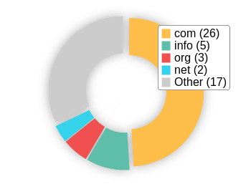 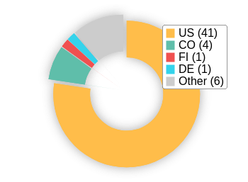

# On-Page Link Structure

We found 74 total links. 15% of your links are external links and are sending authority to other sites. 1% of your links are nofollow links, meaning authority is not being passed to those destination pages.

# Friendly Links

Your link URLs appear friendly (easily human or search engine readable).

Usability

# Your usability needs improvement



**F**

Your page has usability issues across devices. Usability is important to maximize your available audience and minimize user bounce rates (which can indirectly a ect your search engine rankings).

# Device Rendering

This check visually demonstrates how your page renders on di erent devices. It is important that your page is optimized for mobile and tablet experiences as today the majority of web tra c comes from these sources.

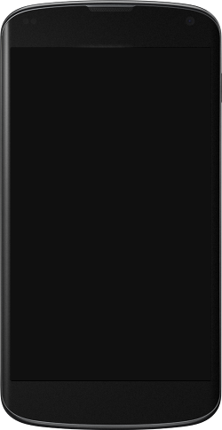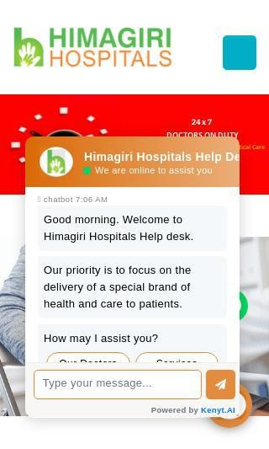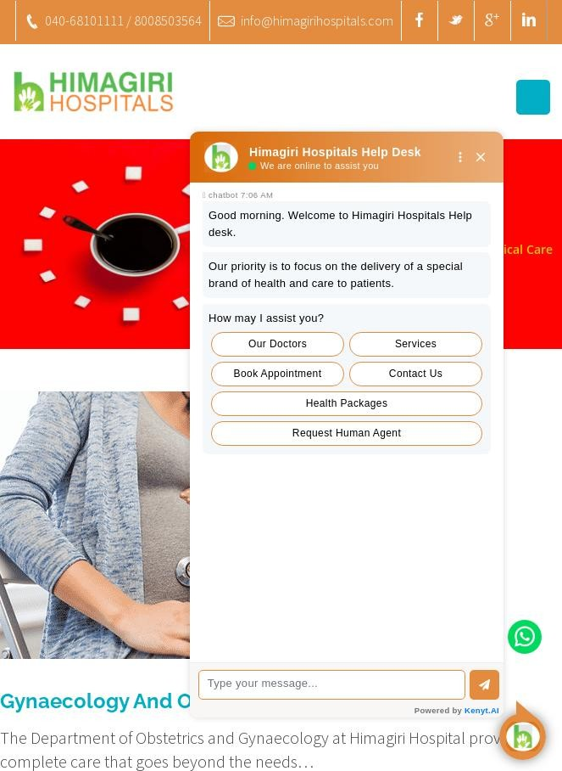

# Google's Core Web Vitals

Your page has failed Google's Core Web Vitals assessment.

Core Web Vitals are UI metrics created by Google that measure page experience and are becoming increasingly important as a ranking factor.

Largest Contentful Paint (LCP)

First Input Delay (FID)

Cumulative Layout Shift (CLS)

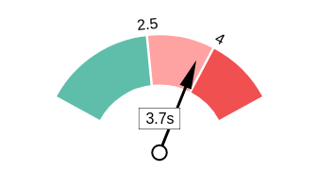 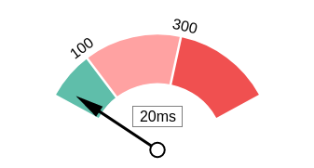 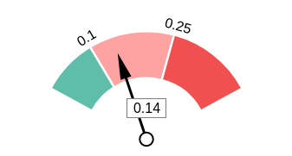

# Use of Mobile Viewports

Your page speci es a viewport matching the device's size, allowing it to render appropriately across devices.

# Google's PageSpeed Insights - Mobile

Google is indicating that your page is scoring poorly on their Mobile PageSpeed Insights evaluation.

Note that this evaluation is being performed from US servers and the results may di er slightly from an evaluation carried out from Google's PageSpeed Web Interface as that reporting localizes to the region in which you are running the report.

Google has indicated that the performance of a webpage is becoming more important from a user and subsequently ranking perspective.



**18**

Lab Data Value

First Contentful Paint 5.9 s

Opportunities Estimated Savings

Speed Index 26.5 s

Serve images in next-gen formats 11.4 s

Defer o screen images 6.6 s

Largest Contentful Paint 28.4 s

Reduce unused JavaScript

4.95 s

Time to Interactive 29.7 s

Total Blocking Time 1.78 s

Cumulative Layout Shift 0.013

Eliminate render-blocking resources

3.36 s

Reduce unused CSS 2.4 s

Properly size images 3 s

E ciently encode images 1.05 s

Avoid multiple page redirects 0.63 s

Minify CSS 0.45 s

Enable text compression 0.3 s

Avoid serving legacy JavaScript to

modern browsers

0.15 s

# Google's PageSpeed Insights - Desktop

Google is indicating that your page is scoring poorly on their Desktop PageSpeed Insights evaluation.

Google has indicated that the performance of a webpage is becoming more important from a user and subsequently ranking perspective.



**36**

Lab Data Value

First Contentful Paint 2.5 s

Opportunities Estimated Savings

Speed Index 7.3 s

Largest Contentful Paint 5.9 s

Time to Interactive 6.1 s

Eliminate render-blocking resources

Serve images in next-gen

formats

1.8 s

1.49 s

Total Blocking Time

0.05 s

Properly size images

1.24 s

Cumulative Layout Shift 0.788

Reduce initial server response time

1.15 s

Reduce unused JavaScript 0.72 s

Defer o screen images

0.76 s

Reduce unused CSS

0.36 s

Avoid multiple page redirects 0.19 s

E ciently encode images

0.16 s

# Flash Used?

No Flash content has been identi ed on your page.

# iFrames Used?

Your page appears to be using iFrames.

iFrames are discouraged as they can complicate navigation of content in mobile and have historically been harder to index for search engines.

# Favicon

Your page has speci ed a favicon.

# Email Privacy

Email addresses have been found in plain text.

We recommend removing any plain text email addresses and replacing them with images or contact forms. Plain text email addresses can be susceptible to scrapers and email spammers.

# Legible Font Sizes

There is some text on your page that is small and may not be legible enough for particular users.

We recommend reviewing all text on your page in di erent devices to ensure that it is of appropriate size.

# Tap Target Sizing

The links and buttons on your page appear to be appropriately sized for a user to easily tap on a touchscreen.

Performance Results

# Your performance needs improvement



**F**

Your page's performance has various issues that may be adversely a ecting users. Performance is important to ensure a good user experience, and reduced bounce rates (which can also indirectly a ect your search engine rankings). We recommend addressing the highlighted factors below.

# Page Speed Info

Your page loads slowly.

Page load speed is critical to ensuring good user experience and is becoming a more important ranking factor. Load speed can be impacted by a multitude of factors however and may need technical resources to investigate.

Server Response All Page Content Loaded All Page Scripts Complete

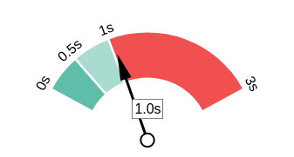 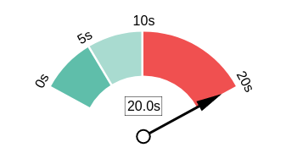 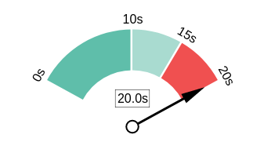

# Download Page Size

Your page's le size is quite large which, regardless of other optimizations, can reduce load speed and impact user experience.

A general rule is to keep your page under 5MB in total le size.

Download Page Size Download Page Size Breakdown

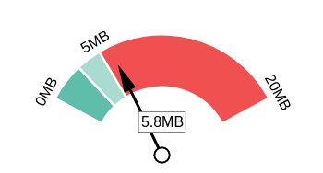 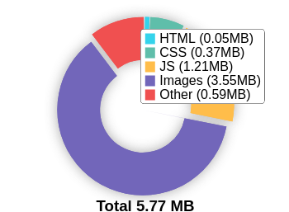

# Website Compression (Gzip, Deflate, Brotli)

Your website appears to be using a reasonable level of compression.

Compression Rates Raw Page Size Breakdown

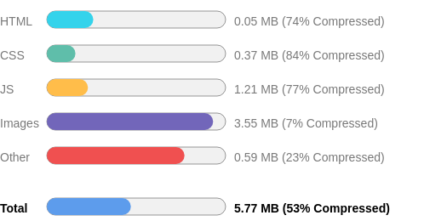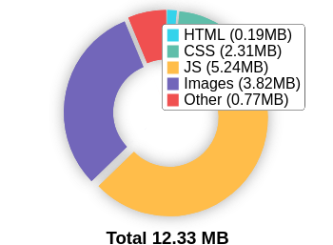

# Number of Resources

This check displays the total number of les that need to be retrieved from web servers to load your page.



**155**

Total Objects

**6**

Number of HTML Pages

**49**

Number of JS Resources

**23**

Number of CSS Resources

**52**

Number of Images

**25**

Other Resources

# Google Accelerated Mobile Pages (AMP)

This page does not appear to have AMP Enabled.

# JavaScript Errors

Your page is not reporting any JavaScript errors.

# HTTP2 Usage

Your website is using the recommended HTTP/2+ protocol.

# Optimize Images

Your page appears to include images which are poorly optimized.

Properly formatting and compressing images can have a signi cant impact on page load performance.

# Minification

Some of your JavaScript or CSS les do not appear to be mini ed.

Mini cation is a reasonably simple way to reduce page size, and subsequently load time.

# Deprecated HTML

No deprecated HTML tags have been found within your page.

# Inline Styles

Your page appears to be using inline styles.

Inline styles are an older coding practice and discouraged in favor of using CSS style sheets, due to their ability to degrade page load performance and unnecessarily complicate HTML Code.

Social Results

# Your social could be better



**D**

You do not appear to have a strong social presence or level of social activity (or we may just not be able to see your pro les!). Social activity is important for customer communication, brand awareness and as a marketing channel to bring more visitors to your website. We recommend that you have all of your pro les listed on your page for visibility, and work to build a following on those networks.

# Facebook Connected

Your page has a link to a Facebook Page.

# Facebook Open Graph Tags

We have not found Facebook Open Graph Tags on your page.

Facebook Open Graph Tags are a type of structured data that can be placed on your page to control what content is shown when a page is shared on Facebook.

# Facebook Pixel

We have not detected a Facebook Pixel on your page.

Facebook's Pixel is a useful piece of analytics code that allows you to retarget visitors if you decide to run Facebook Ads in future.

# Twitter Connected

Your page has a link to a Twitter pro le.

# Twitter Cards

We have not detected Twitter Cards on your page.

Twitter Cards are a type of structured data that can be placed on your page to control what content is shown when a page is shared on Twitter.

# Instagram Connected

No associated Instagram pro le found linked on your page

# LinkedIn Connected

Your page has a link to a LinkedIn pro le.

# YouTube Connected

No associated YouTube channel found linked on your page.

# YouTube Activity

No associated YouTube channel found linked on your page.

Local SEO

# Local Business Schema

No Local Business Schema identi ed on the page.

# Google Business Profile Identified

A Google Business Pro le was identi ed that links to this website.



Himagiri Hospitals

# Google Business Profile Completeness

The important business details are present on the Google Business Pro le.

Address plot no 4, 5,23 & 24, Old Mumbai Hwy, Indira Nagar, Gachibowli, Hyderabad, Telangana 500032, India

Phone +91 40 6810 1111

Site <http://www.himagirihospitals.com/>

# Google Reviews

The Google Business Pro le has a good rating and review count.

4.2

★★★★★

3581 reviews

Rating

5

4

3

2

1

Technology Results

# Technology List

These software or coding libraries have been identi ed on your page.

Technology Version



Apache HTTP Server

 Bootstrap



Contact Form 7 5.1.7

 Google Analytics



Google Maps

 jQuery



jQuery Migrate

 MySQL



PHP 7.2.34

 reCAPTCHA



Slider Revolution

WordPress



wpBakery

# Server IP Address

166.62.30.148

# DNS Servers

ns33.domaincontrol.com ns34.domaincontrol.com

# Web Server

Apache

# Charset

text/html; charset=UTF-8



https://www.thepatternscompany.com/

**The Purpose of a Business is to create a Customer Who Creates Customer’s**

**Thank you**